SQL
Problem Statement
You are working with a pharmacy that wants to track its medicine inventory,suppliers,
Purchases and sales.Your task is to design,create and populate a relational database
that allows user to perform meaningful queries for operations and analysis.
SOLUTION:
CREATE DATABASE PHARMACY_INFO;
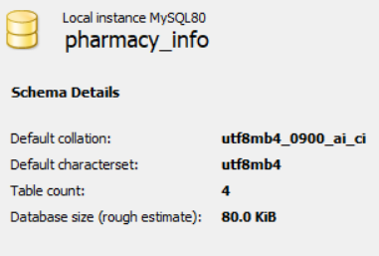
USE PHARMACY_INFO;

CREATE TABLE MEDICINES
(
medicine_id INT,
name VARCHAR(20),
type VARCHAR(20),
unit_price DECIMAL(18,2),
stock_quantity INT ,
expiry_date DATE,
CONSTRAINT PK_MEDICINES primary key (MEDICINE_ID)
);

CREATE TABLE SUPPLIERS
(
supplier_id INT,
name VARCHAR(20),
contact_number VARCHAR(20),
city VARCHAR(10),
CONSTRAINT PK_SUPPLIERS PRIMARY KEY (SUPPLIER_ID)
);
CREATE TABLE PURCHASES
(
purchase_id INT,
supplier_id INT,
medicine_id INT,
quantity INT,
purchase_date DATE,
batch_number VARCHAR(10),
CONSTRAINT PK_PURCHASES PRIMARY KEY (PURCHASE_ID)
);

create table sales
(
sale_id INT,
medicine_id INT,
quantity INT,
sale_date DATE,
total_price DECIMAL(18,2),
constraint PK_SALES PRIMARY KEY(SALE_ID)
);
ALTER TABLE PURCHASES ADD CONSTRAINT FK_PURCHASES_SUPPLIERS FOREIGN KEY (SUPPLIER_ID) REFERENCES SUPPLIERS(SUPPLIER_ID);

ALTER TABLE PURCHASES ADD CONSTRAINT FK_PURCHASES_MEDICINES FOREIGN KEY (MEDICINE_ID) REFERENCES MEDICINES(MEDICINE_ID);
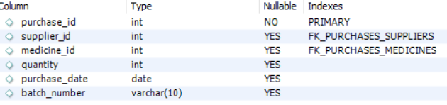

ALTER TABLE SALES ADD CONSTRAINT FK_SALES_MEDICINES FOREIGN KEY (MEDICINE_ID) REFERENCES MEDICINES(MEDICINE_ID);
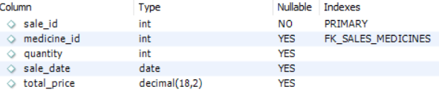
Practice Questions
DDL:
1. Add a column ‘manufacturer’ to the Medicines table.
ALTER TABLE MEDICINES ADD MANUFACTURER VARCHAR(20);
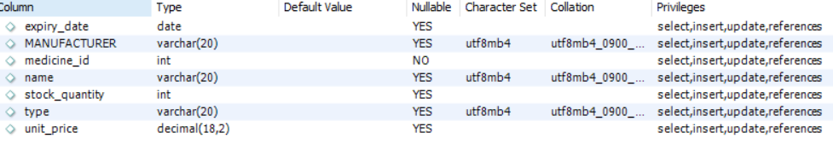
2. Rename the column ‘contact_number’ to ‘phone’ in Suppliers.
ALTER TABLE SUPPLIERS RENAME COLUMN CONTACT_NUMBER TO PHONE;
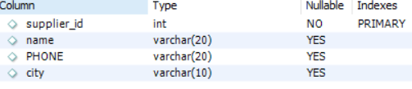
INSERT INTO MEDICINES VALUES(101,'PARACETAMOL','TABLET',2.50,500,'2026-05-20','CIPLA');
INSERT INTO MEDICINES VALUES(102,'COUGH SYRUP','SYRUP',45.00,150,'2025-03-10','SUN PHARMA');
INSERT INTO MEDICINES VALUES(103,'INSULIN','INJECTION',250.00,500,'2026-09-01','DABUR INDIA');
INSERT INTO MEDICINES VALUES(104,'VITAMIN C','TABLET',1.20,1000,'2027-01-05','BICON');
INSERT INTO MEDICINES VALUES(105,'ALBENDAZOLE','TABLET',8.50,500,'2026-12-12','HIMALAYA');

INSERT INTO SUPPLIERS VALUES(201,'HEALTHPLUS PHARMA','987456321','MUMBAI');
INSERT INTO SUPPLIERS VALUES(202,'MEDLIFE DISTRIBUTORS','1234244544','DELHI');
INSERT INTO SUPPLIERS VALUES(203,'CAREWELL','9567898461','BANGALORE');
INSERT INTO SUPPLIERS VALUES(204,'SUNRISE MEDICO','3456789213','CHENNAI');
INSERT INTO SUPPLIERS VALUES(205,'APEX DRUGS LTD','2344567892','MUMBAI');
INSERT INTO PURCHASES VALUES(301,201,101,200,'2025-01-10','BATCH-101-A');
INSERT INTO PURCHASES VALUES(302,202,103,50,'2025-02-05','BATCH-103-B');
INSERT INTO PURCHASES VALUES(303,203,104,20,'2025-03-22','BATCH-104-C');
INSERT INTO PURCHASES VALUES(304,204,102,100,'2025-04-15','BATCH-102-D');
INSERT INTO PURCHASES VALUES(305,205,104,500,'2025-05-30','BATCH-105-E');
INSERT INTO PURCHASES VALUES(306,202,103,50,'2025-02-05','BATCH-102-F');

INSERT INTO Sales VALUES(401, 101, 50, '2025-01-15', 125.00);
INSERT INTO Sales VALUES(402, 102, 30, '2025-02-20', 262.50);
INSERT INTO Sales VALUES(403, 103, 10, '2025-03-28', 450.00);
INSERT INTO Sales VALUES(404, 105, 100, '2025-04-05', 120.00);
INSERT INTO Sales VALUES(405, 104, 5, '2025-04-25', 1250.00);
INSERT INTO Sales VALUES(406, 101, 40, '2025-05-15', 100.00);

SELECT * FROM MEDICINES;
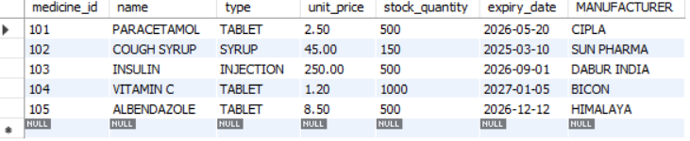

SELECT * FROM SUPPLIERS;
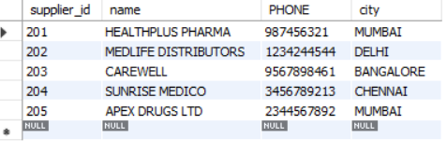

SELECT * FROM PURCHASES;

SELECT * FROM SALES;


DML:
3. Insert a new medicine 'Amoxicillin'.
INSERT INTO MEDICINES VALUES(106,'AMOXICILLIN','TABLET',20.5,500,'2026-05-20','SUN_PHARMA');
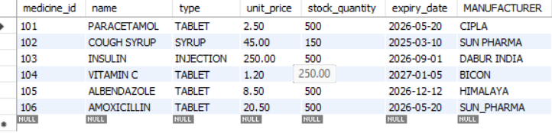

4. Update all medicine prices by 10%.
UPDATE MEDICINES SET UNIT_PRICE=UNIT_PRICE+0.1*UNIT_PRICE;
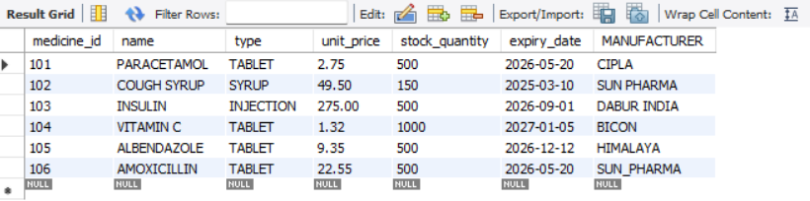
5. Delete medicines that are expired.
DELETE FROM MEDICINES WHERE EXPIRY_DATE<current_date();
SELECT * FROM MEDICINES;
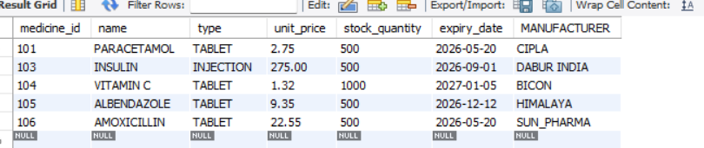
Aggregations:
6. Find total sales revenue per medicine.
SELECT m.name AS Medicine, SUM(s.total_price) AS Total_Revenue
FROM Sales s
JOIN Medicines m ON s.medicine_id = m.medicine_id
GROUP BY m.name;
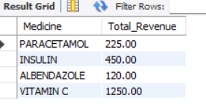
7. Find the supplier who provided the maximum quantity.
SELECT s.name AS Supplier, SUM(p.quantity) AS Total_Quantity
FROM Purchases p
JOIN Suppliers s ON p.supplier_id = s.supplier_id
GROUP BY s.name
ORDER BY Total_Quantity DESC LIMIT 1;
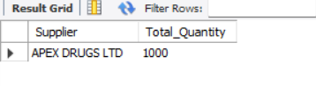
8. Total units sold per medicine type.
SELECT m.type AS Medicine_Type, SUM(s.quantity) AS Total_Sold
FROM Sales s
JOIN Medicines m ON s.medicine_id = m.medicine_id
GROUP BY m.type;
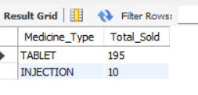
Subqueries:
9. Medicines with stock below average.
SELECT name, stock_quantity
FROM Medicines
WHERE stock_quantity < (SELECT AVG(stock_quantity) FROM Medicines);
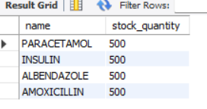
10. Medicines never sold.
SELECT m.name
FROM Medicines m
WHERE m.medicine_id NOT IN (SELECT DISTINCT medicine_id FROM Sales);
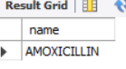
HAVING:
11. Suppliers with total supplied quantity > 500.
SELECT s.name AS Supplier, SUM(p.quantity) AS Total_Supplied
FROM Purchases p
JOIN Suppliers s ON p.supplier_id = s.supplier_id
GROUP BY s.name
HAVING SUM(p.quantity) > 500;
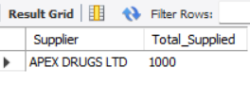
12. Medicine types where avg. price > ₹100.
SELECT type, AVG(unit_price) AS Avg_Price
FROM Medicines
GROUP BY type
HAVING AVG(unit_price) > 100;
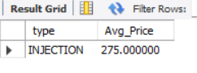
More Practice Questions
JOINS:
13. List all purchase records along with medicine and supplier names.
SELECT p.purchase_id, m.name AS Medicine, s.name AS Supplier, p.quantity, p.purchase_date
FROM Purchases p
JOIN Medicines m ON p.medicine_id = m.medicine_id
JOIN Suppliers s ON p.supplier_id = s.supplier_id;
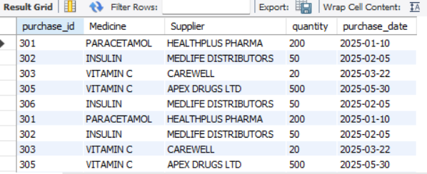

14. Show all sales with corresponding medicine name and type.
SELECT s.sale_id, m.name AS Medicine, m.type, s.quantity, s.sale_date, s.total_price
FROM Sales s
JOIN Medicines m ON s.medicine_id = m.medicine_id;
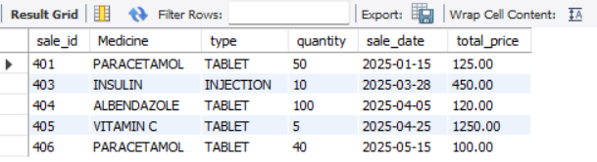
DATE FUNCTIONS:
15. List medicines that will expire within the next 90 days.
SELECT name, expiry_date
FROM Medicines
WHERE expiry_date BETWEEN CURDATE() AND DATE_ADD(CURDATE(), INTERVAL 90 DAY);
There is no such medicine given in a dataset.
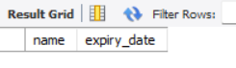

16. Count number of sales made in the last 30 days.
SELECT COUNT(*) AS Sales_Last_30_Days
FROM Sales
WHERE sale_date >= DATE_SUB(CURDATE(), INTERVAL 30 DAY);
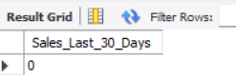

STRING FUNCTIONS:
17. List supplier names that start with the letter 'S'.
SELECT name
FROM Suppliers
WHERE name LIKE 'S%';
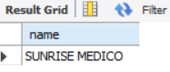

18. Convert all medicine names to uppercase.
SELECT UPPER(name) AS Medicine_Name_Uppercase FROM Medicines;
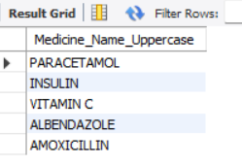

COMPLEX QUERIES:
19. Show the top 3 best-selling medicines by quantity.
SELECT m.name AS Medicine, SUM(s.quantity) AS Total_Sold FROM Sales s JOIN Medicines m ON s.medicine_id = m.medicine_id GROUP BY m.name ORDER BY Total_Sold DESC LIMIT 3;
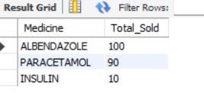
20. List medicines that were purchased but never sold.
SELECT DISTINCT m.name FROM Medicines m JOIN Purchases p ON m.medicine_id = p.medicine_id WHERE m.medicine_id NOT IN (SELECT DISTINCT medicine_id FROM Sales);
There is no such given medicine available in a dataset.
